SAP functionality offers the choice of automating your accrual processing. Learn about the SAP R/3 Accrual Engine and see how it compares to R/3's accrual/deferral feature. (Source: Financials Expert).

Key Concept
The Accrual Engine, allows you to manage your accruals and calculate the amount of the accruals in one central location. The Accrual Engine improves on its predecessor in that it allows for a more flexible calculation of the amount to be accrued. Its drawback is that it must be provided with an amount; it cannot determine an amount to accrue from data posted elsewhere in the system.
SAP has a functionality to help you calculate and post month-end accruals within R/3. The Accrual Engine can help create, calculate, and manage all of your accruals for processing, which saves precious time during month- end close. I will examine the Accrual Engine and what it offers compared to R/3's accrual/deferral feature.
R/3 provides functionality for entering, posting, and the subsequent reversal postings of those accrual entries using the accrual/deferral feature. However, this functionality doesn't differ much from creating a normal journal entry. The two main differences are that when you use the accrual/deferral feature, you enter a reversal date on the entry (created using transaction code FBS1), and R/3 generates reversal postings using program SAPF080R (transaction F.81).
The accrual/deferral feature does not, however, calculate the amount entered in the accrual postings. It allows for entering storage of the amount, accounts, and cost objects impacted and automatic reversal on a specified date, but cannot calculate the accrual amount if it changes each period.
For example, if fringe benefits are accrued at month-end and the amount of fringe benefits depends on the amount of salaries as well as headcount, the accrual/deferral entry must be manually changed at each period-end in order to reflect the correct amount. As a result, many companies calculate the accrual amounts outside of R/3.
The Accrual Engine
The Accrual Engine essentially functions as a separate ledger for accrual entries within the FI module. The accrual/deferral entries are entered, managed, and processed within the Accrual Engine. In addition to the G/L documents, the engine creates separate documents for entries that are processed internally. The results are then passed on to the FI module. The reversal process occurs similarly.
At month-end, processing takes place within the Accrual Engine itself. The accruals can be checked or simulated and their results validated prior to their posting within the G/L.
Many clients whom I've assisted over the years want a feature that can determine accrual amounts based on posted data. R/3 provides some of this functionality with other features, such as its Revenue Recognition tool, but this is lacking in the Accrual Engine, which may be a key sticking point with some SAP customers.
Processing Accruals
Processing accruals within the Accrual Engine occurs via periodic processing runs, which are managed by company code and can be managed by an accrual type. The accrual type is a key feature used within the Accrual Engine that groups accrual entries for the purpose of managing and processing the entries.
As an example, consider a monthly accrual for electricity. Accrued electricity expenses can be grouped with other utility expense-related accruals, such as telephone expenses, into a utility accrual type (Figure 1). You can process this type for posting as a whole.
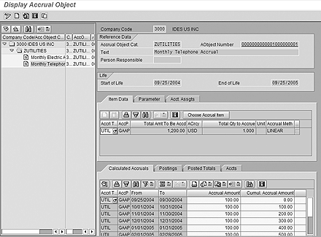
Figure 1
Process utility accrual types

The engine creates each accrual entry (via transaction code ACACTREE01) as an accrual object and assigns it to an accrual type. The accrual type within the engine manages the processing of the accruals. You only need to enter the lump sum of the entire amount to be accrued, because the accrual method (defined within configuration) specifies how the amount is to be broken down and posted to the individual periods.
In addition, you can break down the entries by cost object (i.e., cost center, internal order, etc.). For each entry, you specify the amount, quantity, and accrual method, as well as the cost objects for the postings.
In Figure 1, an accrual type for utilities expenses contains two accruals: one for electricity expenses and the other for telephone expenses. When you select the accrual object, the Accrual Engine displays the details of the entry and the proposed postings.
Once the accruals are defined, they are processed in a posting run and posted to FI using transaction ACACACT. This process is similar to executing a depreciation run in that only one planned accrual run can be executed per fiscal period. After the accrual is posted to FI and CO, the details are shown on the Posted Totals tab (Figure 2). Then the reversal process occurs by calling transaction ACACREVERS to post the reversing entries in subsequent periods.
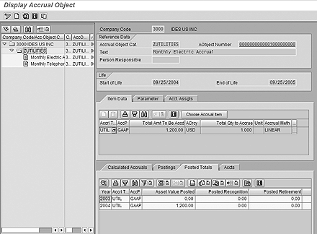
Figure 2
Details of the planned accrual run on the Posted Totals tab

Key Features and Configuration
Some customization must be performed in order to use the Accrual Engine, the key components of which are described here. First, you must assign the company codes to the Accrual Engine.
As described earlier, you organize accruals into accrual types within the Accrual Engine. This helps with processing and account determination. You then can configure all accruals within an accrual type to post to the same set of G/L accounts and document types, while other accrual types (such as ones defined for insurance, salaries, fringe benefits, etc.) are posted to different G/L accounts and document types. The benefit of this configuration is that you do not need to maintain individual accrual entries to set or maintain the G/L accounts to which they post. In effect, you are saving a methodology for managing and creating the entry, rather than saving an entry. Therefore, if the accounts change, you simply change the account determination, not every individual entry.
The accrual method defines how the amount of the accrual should be spread over the life of the accrual. R/3 provides standard methods to calculate amounts using methodologies such as straight-line or declining-balance. Additionally, you can define a custom function module to calculate the accrual breakouts by fiscal period. Ultimately, the accrual method feature provides the ability to create a custom calculation for the monthly amount for the accrual entry.
The Accrual Engine can determine the G/L accounts and document types used for posting accruals using the values of other fields. It can also define different G/L accounts for opening and closing postings (separate and apart from the normal month-end postings). Also, the Accrual Engine can use different G/L accounts (and document types) for different accrual types, as described earlier. It can use symbolic account determination for further flexibility within G/L account determination.
As with any other subledger used within the FI or CO modules, you must configure number ranges for Accrual Engine documents, logs used when processing the accruals, as well as the accrual posting runs themselves. See Table 1 for a summary of features that the Accrual Engine and accrual/deferral entries provide.
Features | Accrual Engine | Accrual/deferral feature
Program to auto-reverse accruals
Separate accrual ledger
Ability to manage/analyze accruals by type
Function module in which to calculate accruals
Flexible account determination

Table 1 | Characteristics of the Accrual Engine and accrual/deferral feature
When deciding whether the Accrual Engine is right for your business, keep in mind the extent of functionality that you require for your accrual postings. You may want to consider that the Accrual Engine creates separate documents and must be managed like a separate ledger. It also provides for the management and analysis of accruals by type.
The Accrual Engine can provide assistance through the customizable function module when the calculation of accrual amounts is a cumbersome, offline process or when retrieving and calculating data requires a significant effort. Reviewing your requirements with regard to what the functionality offers will enable you to determine whether the Accrual Engine or accrual/deferral feature is the right solution for automating accruals in your accounting department.
Period-end manual accrual postings typically have costs assigned to more than one account assignment (e.g., cost center). Such an FI document would have as many line items as there are account assignments (e.g., for each cost center). With the use of a standard SAP Business Add-In (BAdI) in the Accrual Engine, you can post accounting documents processed via the accrual run (transaction ACACACT) with multiple account assignments (e.g., cost center and profit center). This anticipates and eliminates manual adjustment postings and enables efficient accounting and reporting.
I’ll start with an overview of the Accrual Engine, including customizing settings you need to make, before taking you through a simple example to show you how to process accounting documents with multiple account assignment objects.

Accrual Engine Overview
The Accrual Engine is available as of SAP R/3 4.7, via the extension set (version 1.10, 2.0). The Manual Accruals component within Accrual Engine enables you to calculate and post accruals in SAP General Ledger automatically. It is a useful feature that helps set up accruals based on user-defined criteria, which handles calculation, recalculation, and posting on a periodic basis. It provides a virtual accrual subledger that can create self-correcting, mass processing of accruals that are tied together via business documents (e.g., contracts or orders).
The functions in Manual Accruals support the use of parallel valuation methods. This means that you can calculate and post accruals according to different accounting principles simultaneously. To use the functions in Manual Accruals, you need to make extensive Customizing settings via the menu path Financial Accounting (New) > General Ledger Accounting (New) > Business Transactions > Manual Accruals, and then the associated paths below.
Key customizing steps include:
- Assigning the company code to the manual accruals component (from Basic Settings > Assign Company Codes)
- Defining accounting principles from which you calculate and post accruals (from Basic Settings > Accounting Principles > Define Accounting Principle)
- Assigning the company code to accounting principles (from Basic Settings > Accounting Principles > Assign Accounting Principle to Company Code)
- Defining accrual types, which divide the accrual item into, for example, costs, revenues, and receivables, and define how accruals are to be calculated and posted. From Manual Accruals, follow menu path Basic Settings > Define Accrual Types.
- Defining accrual methods — how the accrual amounts have to be accrued (e.g., linear or declining balance). You can reach this setting by following menu path Accrual Calculation > Accrual Methods > Define Accrual Methods.
- Defining account determination, specifying the document type and SAP General Ledger accounts to be picked automatically when Accrual Engine documents are passed on to Accounting. Follow menu path Accrual/Deferral Posting > Account Determination.
You can also tailor certain functions, such as accrual methods, to meet specific business requirements.
Note
You can also consult SAP Building Block N73 - Period End Closing for Financial Accounting, which provides a configuration guide (section 3.4: manual accruals) and business process procedure (section 6: manual accruals).

Scenario
Costs for contracts and orders that are to be accrued are set up as accrual objects and are processed on a periodic basis. At present, you can set up such an object using transaction ACACTREE01 with only one account assignment (e.g., cost center). You would then transfer this assignment to the accounting document via the periodic accrual run, which is done using transaction ACACACT.
You can create an accrual object for a company code using transaction ACACTREE01 or by following menu path Accounting > Financial Accounting (New) > General Ledger (New) > Periodic Processing > Manual Accruals > Create Accrual Objects (Figure 1). Then input basic information such as Accrual Object Cat. (category), AObject Number (name of the accrual object), Start of Life and End of Life dates, and the Accrual Type.
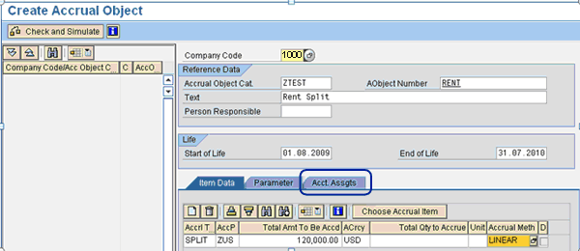
Figure 1
Create an accrual object

Click the Acct. Assgts (account assignments) tab (Figure 2). You can see that you can set up the accrual object with only one cost center, which is not ideal. You would have to resort to additional adjustment postings in FI and use Assessment/Distribution Cycles in CO to allocate costs under this cost center to multiple cost centers. With the use of this approach, you avoid additional manual effort and make accounting more efficient.
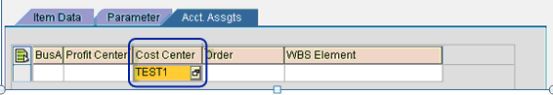
Figure 2
Assign the cost center within the accrual object

Enhancement
SAP provides BAdIs ACEPS_BAPIDOC_MODIFY and ACEPS_PREDOC_MODIFY that you can code to handle this scenario. When an Accrual Engine document is transferred to SAP General Ledger, the system makes a temporary two-line accounting document from the Accrual Engine as Business Application Programming Interface (BAPI) structures and summarizes a number of these temporary two-line documents before transferring them to SAP General Ledger using BAPIs.
With ACEPS_BAPIDOC_MODIFY, you can define and read a custom table and calculate the amount of split for each cost center. You can set up a custom table as an Application Table accessible by end users and access it via a custom transaction code or transaction SM30. Figure 3 shows an example of this with multiple cost centers and corresponding distribution rules (accessed by a custom transaction code).
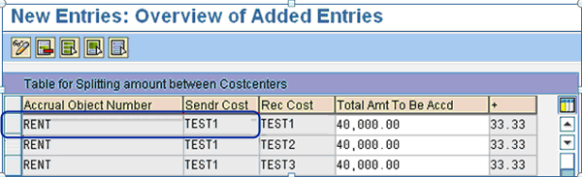
Figure 3
An example table with distribution rules

You can set up the table with the Accrual Object Number as the primary key and the Sendr Cost (sender cost center) as the same as the one assigned in the accrual object. In this example, the Accrual Object Number is RENT for US $120,000 with TEST1 as the sender cost center. I set up the distribution rule to split the accrual cost of the sender cost center between the three receiving cost centers (TEST1, TEST2, and TEST3) in the ratio of 1:1:1. The BAPI computes the split between cost centers and populates necessary information to pass it to the BAdI ACEPS_PREDOC_MODIFY to update it in the FI accounting document. You need to build adequate checks and balances into the table to ensure no duplicate entries are possible and the total of entries matches the total of the accrual object. Then validate any entries made in the table against the corresponding accrual object created to ensure data is consistent. You can set up distribution rules to split the accrual object amount either in terms or fixed amounts or in terms of percentage within the table.
ACEPS_PREDOC_MODIFY allows you to change the FI accounting document before summarization. You need to update the accounting document to include the additional line items with the amount for each account assignment calculated as a result of the above distribution rule. There should be as many additional line items as the number of receiver cost centers you set up in the custom table.
Now that you have created an accrual object and defined the distribution rules, you can process the periodic accrual run using transaction ACACACT or by following menu path Accounting > Financial Accounting (New) > General Ledger (New) > Periodic Processing > Manual Accruals > Start Periodic Accrual Run (Figure 4).
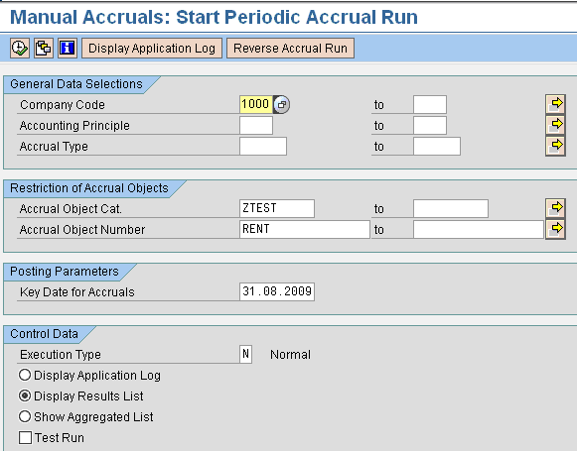
Figure 4
Selection screen of the periodic accrual run

During an accrual run, the system performs the following steps:
- Creates Accrual Engine documents
- Transfers these Accrual Engine documents to SAP General Ledger
- Creates follow-up documents in SAP General Ledger
If you have checked the Test Run check box in Figure 4, the system displays the calculated accruals; if you have not checked it, the posted accruals are displayed instead. Once you execute the periodic accrual run, you see the screen shown in Figure 5. Click the number in the Ref.Doc No column to bring up the document overview screen shown in Figure 6.
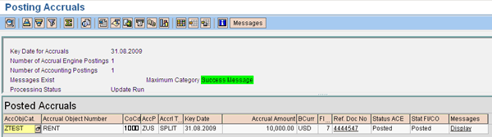
Figure 5
Log of the periodic accrual run

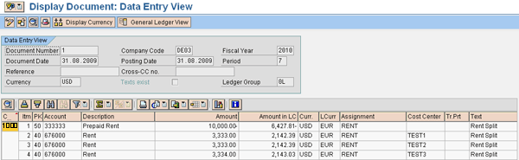
Figure 6
Accounting document generated by transaction ACACACT

You can see that the accounting document generated via Accrual Engine has costs assigned to multiple cost centers. Additional line items are generated for each of the receiving cost centers defined in the custom table. The periodic accrual amount of US $10,000 for the accrual object RENT has been split across cost centers TEST1, TEST2, and TEST3 in the ratio of 1:1:1.

