Closing Cockpit Setup (Source: Financials Expert)
With mySAP ERP Central Component (ECC) 5.0 and 6.0, SAP provides a set of seven tools that you can link and schedule together to speed up all types of closing cycles — monthly, quarterly, and year end. I’ll briefly describe each tool and provide a bit more in-depth description of the least-well-known and most under-used of these tools — SAP Closing Cockpit. For a summary of the other six tools, see the sidebar, “mySAP ERP Fast Close Tools." Closing Cockpit is divided into two basic parts: a template and a task list. I’ll discuss the template in the next section.
Closing Cockpit Template
Figure 1 displays a typical Closing Cockpit template. You can configure the template from scratch or you can start with a delivered template from SAP. No matter which type of Closing Cockpit you use, you can configure a monthly closing template once and then reuse it multiple times as the year progresses. Within this view, you can see three primary information panels found within any Closing Cockpit template.
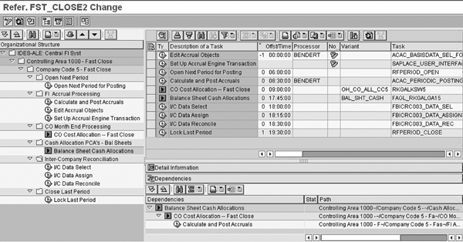
Figure 1
The three primary information panels of a Closing Cockpit template
The first information panel on the left contains the template task list. You can configure the complete task list containing the closing steps, called tasks, here. You can configure these tasks individually, and then attach them to transaction codes, job programs, or job variants. In Figure 1, this task list is located on the left side of the screen and set up to run the assigned tasks in Controlling Area 1000 and Company Code 5 (0005).
You can configure the task list to include any other controlling areas and company codes within your system. The individual tasks are assigned to separate folders within the task list hierarchy. The folders can correspond to the major activities found within each closing schedule. For example, in this simple view the major steps in the closing task list are: opening the next period for posting (Open Next Period); using Accrual Engine to calculate and post accruals (FI Accrual Processing); processing CO month-end using a cost allocation cycle in CO (CO Month End Processing); using the new G/L for FI cash allocation (Cash Allocation PCA’s – Bal Sheets); reconciling inter-company data (Inter-Company Reconciliation); and locking the closing period (Close Last Period). Depending on your choice, the task can link directly to a transaction code, program, or program variant. Each task type selection offers different options depending on the user requirements.
Note
The names listed in these steps are the folder names. The actual steps are listed under each folder.
Closing Cockpit Task List
The second key feature of the template is scheduling the various tasks, which appears in the top-right panel of Figure 1. This scheduling is based on a 0 day basis. A monthly close often is the first day of the new accounting period. In the Offst/Time column, you can see the scheduling begins on -1 and ends on +1 day. That means that the various scheduled tasks operate on either side of a specific date once the user copies the template into a specific task list that users select from a specific date. Also, note that in addition to the day schedule, the template owner schedules each task to begin at a specific time during the day.
The third key feature of the template is the ability to control task execution sequence by linking or setting dependencies among tasks, which you can see in the lower- right panel of Figure 1. This means you can set priorities among tasks to ensure that the various tasks execute in order of precedence. In this example, you do not want the CO cycle to run prior to executing the monthly accrual that posts additional expenses into the CO cost centers.
By setting the dependencies as shown in the lower-right section in Figure 2, with task priority from the bottom up, you must run the five tasks in the following order: the FI accrual (FI Accrual Processing), CO month- end allocations (CO Month End Processing), FI cash balance sheet distribution (Cash Allocation PCA’s – Bal Sheets), inter-company reconciliation (Inter-Company Reconciliation), and finally closing the last period (Close Last Period). In fact, if the user for some reason activates the CO cycle manually prior to the FI accrual, an error status flag results and the job halts, followed by a posted message within the task list stating that the FI accrual must run successfully prior to the CO cycle. Note that this example assumes the typical FI accruals should run and post the accrual amounts into the CO cost centers prior to the CO cost allocation cycles; therefore, the dependencies are set to avoid an early activation of the CO cost allocation cycles.
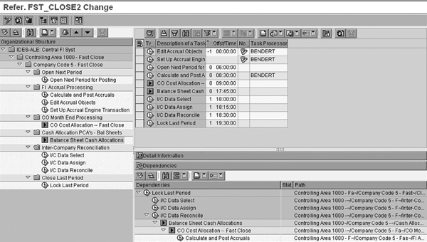
Figure 2
Dependencies among tasks

Additional Closing Cockpit Template Points
Here are some additional tips to remember regarding the Closing Cockpit template. The example shown in this article is very simple; undoubtedly, the template required within your environment will be more complex. During the template configuration you should ensure that you have a clear understanding of the closing steps and the order in which you must complete them. Next, you have to decide how to execute each task within the template — either manually or with a job variant. The option you choose depends on how automatic or hands-off you wish the task list to be. If you want to control how to start and execute each task, then you can start each task by hand; if you wish the tasks to start at a scheduled time without manual intervention, you can configure them with a job variant.
Finally, it is quite easy to make changes to Closing Cockpit as required. The executable task list is simply a copy of the most current template configuration. Closing Cockpit uses any changes that you make within the template master in the next closing cycle, copying the task list from the new, revised Closing Cockpit template.
Copy the Template into a Task List
Once you’ve completed the template configuration, the next step is copying the template into a usable and executable task list. Figure 3 displays the actual configuration window to copy the template into an executable task list.
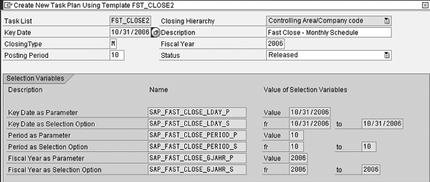
Figure 3
Set up the task list
The key required fields when setting up the task list are Key Date and Status. The major difference between the task list and the template is that you can only execute the tasks from a task list that is in Released status and tied to a Key Date that you use for day-by-day scheduling of each task. You can set up multiple task lists at one time, such as an entire year’s closing task lists.
In this example, I’ve copied the template into a task list and assigned a specific date of 10/31/2006. Further, the new task list is identified as a monthly schedule task list, assigned to post into Posting Period 10 during Fiscal Year 2006. Finally, the Status is set to Released, which means the task list becomes active and available for use. Also with this setting the task list automatically schedules tasks and executes them based on the key date assigned to the task list.
Figure 4 displays the newly configured, ready-to-execute task list. At first glance, you might notice how similar it is to the template. However, some significant differences exist. The three columns circled in Figure 4 — Status, Spool, and JobDisplay — contain job status information. Remember, the major difference between the template and the task list is that you have to use the task list to execute the various tasks. These three columns display the status and results of each task as it completes. Also, within the Status column, an indicator light appears to set the task status as successful, still running, or ended with an error.
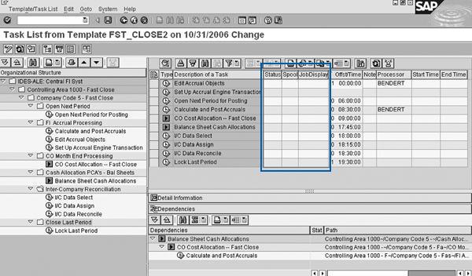
Figure 4
Configured task list
At this point, the task list can execute the tasks according to the assigned schedule. The system arrives at the assigned schedule by setting a specific calendar date and time to execute the task in the task list based on the scheduled day of the task. The first tasks scheduled in the October 31 task list are Edit Accrual Objects for existing objects and Set Up Accrual Engine Transaction for new accrual engines (Figure 4). The execute icon tells the user that the task list owner must execute these tasks manually. Also, according to the assigned schedule, the system could complete them one day earlier than the task list key date, or October 30. You can confirm this setting under the Offst/Time column where these tasks are set for a -1 day.
The next two tasks, Open Next Period for Posting and Calculate and Post Accruals, are also manual executables. These indicate that there is no status update to the closing cockpits, but you have to remember to check these tasks off manually. Next are two tasks that are configured as job variants, identified by the right arrow icon . These tasks use the assigned job variant to execute the CO allocation and FI cash distribution: CO Cost Allocation – Fast Close and Balance Sheet Cash Allocations. They run automatically based on the scheduled time. As you can see, the CO allocation is scheduled to run at 09:00:00 and the FI cash distribution is scheduled to run at 17:45:00.
Also, again note the task dependencies settings at the bottom of the display. These three tasks must execute successfully in order, from bottom to top. The CO cycle and FI cash allocation do not run if they do not follow the accrual task completion.
In Figure 5, the system activates the task list automatically based on the key date and it is now in mid- execution. In the top section, you can now see status indicators, spool files, and job logs available for review. Starting from the top, you can see that the first two tasks were not executed. They do not have green markers in the Status column, as they are not part of the normal closing process. The note icon tells the task list owner that these tasks were not required. The owner of the specific task created and posted the note.
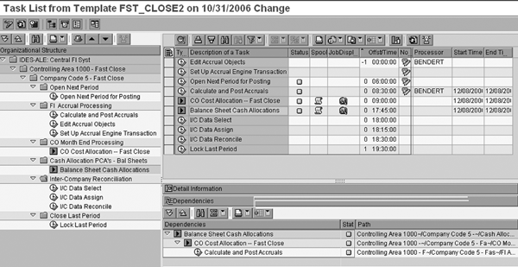
Figure 5
Task list executed
The next task Open Next Period for Posting has a green status. The person responsible for initiating this task assigned the task to convey that you must complete it during the monthly closing cycle. Also, the task owner entered a note in the task list stating that everything is fine and the closing process can proceed.
The next two job variants, Calculate and Post Accruals and CO Cost Allocation – Fast Close, have kicked off the CO cycle and the FI cash distribution cycles at the scheduled time. Each job completed successfully and the system posts job logs and spool files automatically and ready for review.
The next task I/C Data Select (inter-company data selection) is manually executable and is scheduled for 18:00:00.
mySAP ERP Fast Close Tools
mySAP ERP provides several tools in addition to SAP Closing Cockpit that you can use according to your individual needs. It is not necessary to employ all these tools to speed up the closing schedule, but these are the ones that would likely have the most impact:
SAP NetWeaver Portal. SAP NetWeaver Portal provides a customizable single access point to SAP tools.
Accrual Engine. This is a new feature in mySAP ERP that automatically calculates and posts an accrual based on changing requirements. For example, beginning at the first of the year, accounting establishes an automatic accrual to allocate expected income from future rents received. During the year, the amount received does not match the planned amount and you must reset the accrual. As a result of this unplanned change, Accrual Engine can automatically recalculate the necessary monthly accrual amount to ensure the accrual account zeroes out at month end. This eliminates the need to constantly verify and recalculate the monthly accrual as circumstances change.
Inter-Company Reconciliation. One of the most time-consuming tasks for the closing process is reconciling cross- posting between different divisions. Users often perform this tedious task in Microsoft Excel spreadsheets, which takes a long time and can lead to inaccurate results. SAP’s inter- company reconciliation tool provides a cockpit-type option where you can review, adjust, and reconcile all postings as required.
Business Consolidations. Once you have reconciled the inter-company transactions, the next step often is to consolidate or roll up numbers. The new BW/SAP NetWeaver BI InfoCube-based version of SAP’s consolidation tool automates this task. If you link it to the new G/L, you can save even more time as the new G/L eliminates the need for the data staging ledger that is required using the classic G/L version.
mySAP Corporate Performance Monitor (CPM). mySAP CPM offers a highly visible graphic view of results against plan and further analysis of the results against the overall corporate strategy. The management cockpit presents the plan-to-actual view in a graphical/dashboard format. SAP Balanced Scorecard in Strategic Enterprise Management (SEM) allows management to compare the current and forecast results against the overall corporate objectives and strategy.
New G/L in mySAP ERP 2004 and mySAP ERP 2005. Of all the tools SAP provides, the new G/L is likely the one tool to save the most time in the typical financial closing cycle. For example, the new G/L eliminates many of the closing cycle data reconciliation steps — you no longer need FI/CO reconciliation transaction KALC. Also, the new G/L eliminates the month- end build you had to perform via transaction IKEK of the Profit Center Accounting (PCA) balances of A/P or A/R balances. Instead, the new G/L generates a real- time balance sheet posting at the time of document entry.

